Milestone 1

Cogs 121

Brandon Kim

Henry Ou

Chloe Wu

**Team Name:** VRecipe

**Proposal:**

We decided to make a cooking app for vegans and vegetarians. We offer our users recipes from professional cookbook and the homemade recipes. Users can upload their own recipes and rate other’s recipes. Since there are not many recipes and ingredients specifically for vegans and vegetarians, people can explore a variety of new recipes and filter the ingredients. We believe this fits the project theme because none of us are vegetarian/vegan, so our design of the app aims to target people with certain dietary restrictions. We aim to use databases of recipes for vegetarians/vegans for our project in order to provide accurate recipes for our users. As a backup project idea, we’ve thought about websites regarding health for the eldery/children, specialized jobs (medical professionals, teachers,etc.), dietary needs for pets, and an app that would provide care and tips for people suffering from mental illnesses.

**Storyboards:**

![Storyboard 1]

(<https://github.com/ziw173/VVrecipe/blob/master/storyboard%201.HEIC>)

![Storyboard 2]

(<https://github.com/ziw173/VVrecipe/blob/master/storyboard%202.HEIC>)

![Prototype 1-1]

(<https://github.com/ziw173/VVrecipe/blob/master/prototype%201%20(landing%20page).HEIC>)

![Prototype 1-2]

(<https://github.com/ziw173/VVrecipe/blob/master/prototype%201%20home%20page.HEIC>)

![Prototype 1-3]

(<https://github.com/ziw173/VVrecipe/blob/master/prototype%201%20filter%20drop%20down.HEIC>)

![Prototype 1-4]

(<https://github.com/ziw173/VVrecipe/blob/master/prototype%201%20(click%20on%20recipe).HEIC>)

![Prototype 2-1]

(<https://github.com/ziw173/VVrecipe/blob/master/prototype%202%20landing%20page.HEIC>)

![Prototype 2-2

**Prototype 1:**

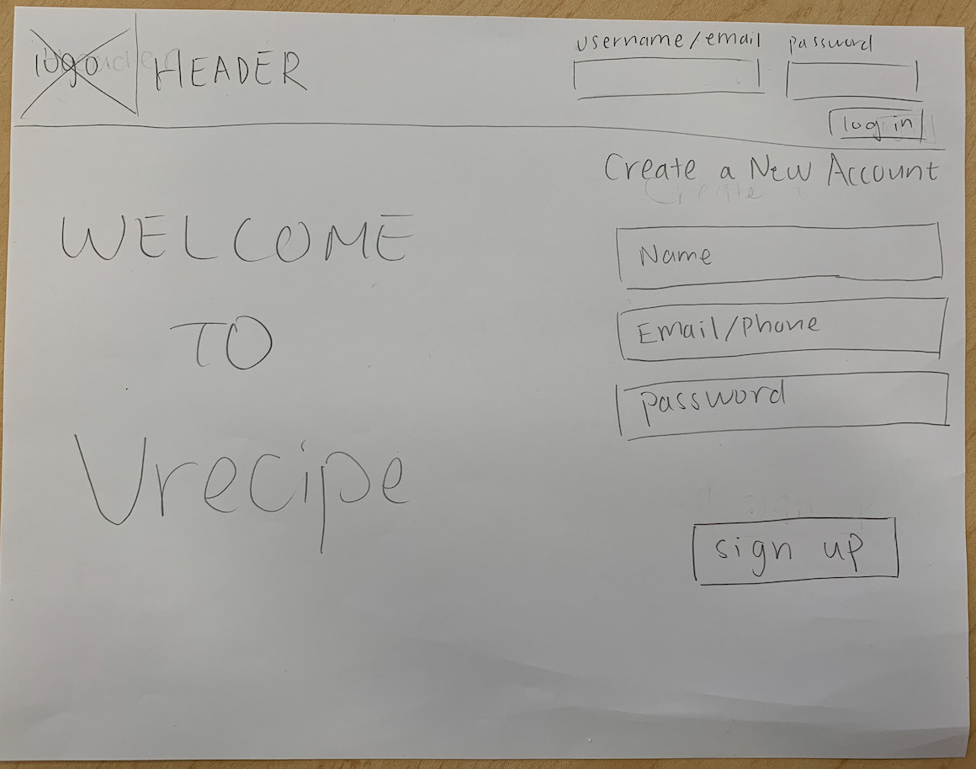

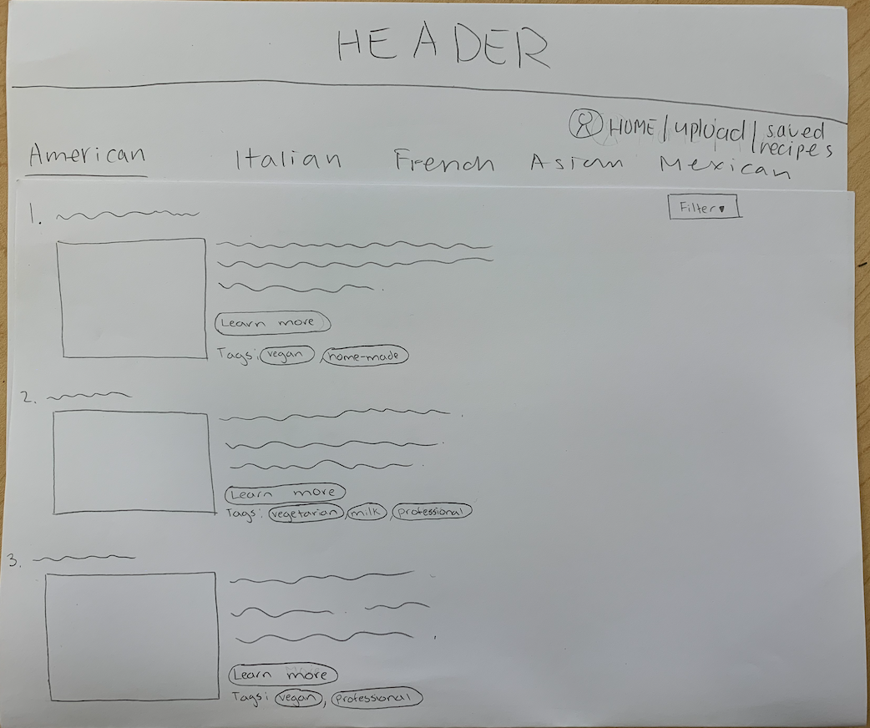

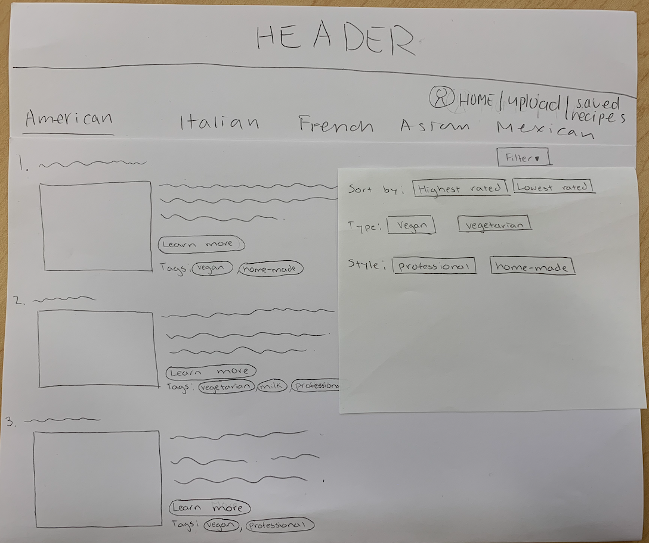

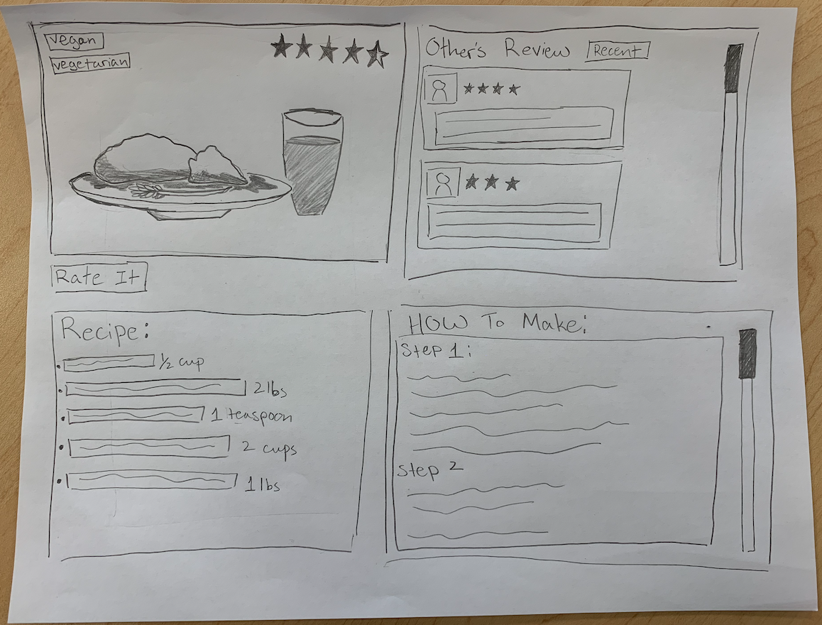

**Prototype 2:**

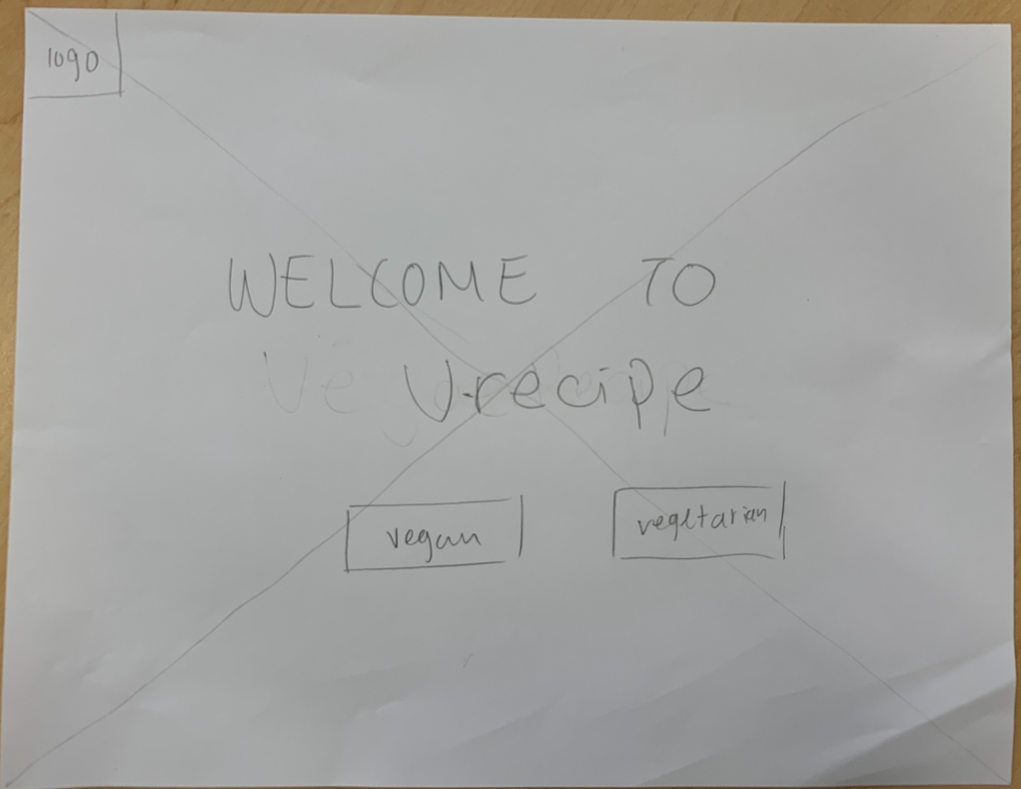**https://github.com/ziw173/VVrecipe/blob/master/storyboard%201.HEIC**

